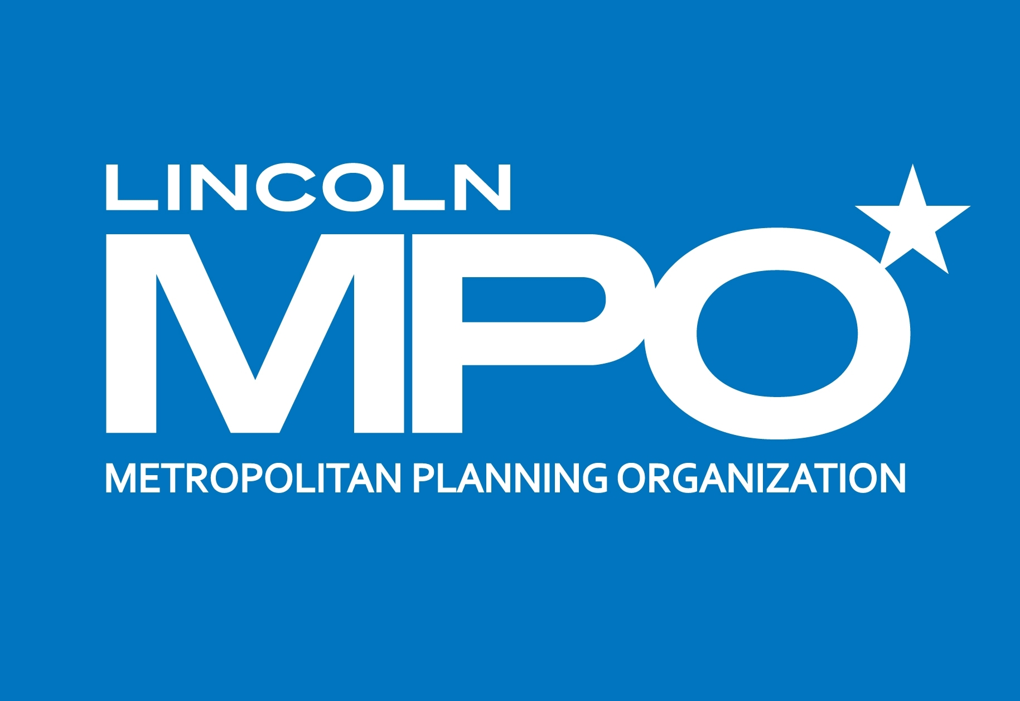
Lincoln Metropolitan Planning Organization

County-City Building
555 South 10th Street - Suite 213
Lincoln, Nebraska 68508
(402) 441-7491

Lincoln MPO 2050 LRTP Update & Lincoln Mobility Plan
Project Oversight & Planning Committee (POP-C) Meeting #5

June 5, 2026 at 8:00
Lincoln-Lancaster Co. Building (555 S. 10th St.)
Room 303

Attendees:
Rachel Christopher, Paul Barnes, Andrew Thierolf, Mia Haschenburger (Lincoln-Lancaster Planning); Robert Partida, Danae Garfield (LTU); Stephanie Rouse (Lincoln Urban Development); Alex Duryea (Lincoln Parks & Recreation); Kim Morrow (Lincoln Sustainability); Larry Legg, Jarrod Walker (Nebraska DOT); Carla Cosier (StarTran).
Consultant Team: Greg Youell, Jenny Young

Agenda:

- Phase 2 Public Inovlvemnet
Greg reviewed the initial results from the Phase 2 public engagement activities. Results from the Open House were shown as well as online engagement to date, with the highest ranking projects for Lincoln Roadway, County roadway, Trails and Bike-Ped. Also the results from the funding activity were shown.

- Revenue Forecast and Funding Scenarios
Jenny presented the revenue forecasts for 2027-2050, and explained the committed/restricted versus remaining flexible funds, which represent about 1/3 of the projected revenues. She described five flexible funding scenarios:
- Business as Planned
- Fix it first
- Safe Streets for Everyone
- Transit & Access Expansion
- Invest in Growth

While all five scenarios have their advantages, Jenny asked the committee to discuss their preferences. Jarrod Walker said that in thinking about it more since the Funding Subcommittee, 3 and 4 seem to have more merit. Kim Morrow agreed that 3 and 4 have merit; would like to see more funding for transit; if we lean in to bike..we already have a good network, let’s be great, address most vulnerable. Stephanie Rouse would like to respond to public engagement. Paul shared that he liked that there is a percentage going to trails and % to multimodal and that 5 seemed to represent realistic pressures. Rachel started to think about the fix it first and how it works with 3,4,5. There was general consensus that the strong support for Lincoln on the Move focuses on preservation, so fix-it-first may not have the same urgency that it had during the development of the last LRTP, and they would like to give some other areas some attention.
Also, discussion about rehab projects should be multimodal too. Danae Garfield said that if there is a 10% project minimum on multimodal components, it would need to be defined what elements count as multimodal.

- LRTP Projects – Preliminary Results
Jenny showed the preliminary results for project rankings based on the evaluation criteria. The committee discussed the initial results.

- Mobility Plan Update
Greg discussed the following elements of the Mobility Plan:
- Mobility Nodes
- Mobility Plan Subcommittee Recap of tools for implementation
  - Zoning Code
  - Complete Streets Plan
  - Comprehensive Plan
  - Vision Zero Action Plan
  - TIF Policy & Review Plans
  - Climate Action Plan
  - Transit Development Plan
  - Age Friendly Action Plan
- Sidewalk gap analysis
- Mobility Plan Key Themes
  - Safety
  - Mobility Nodes & intermodal connectivity
  - MOD & Complete Streets
  - Transportation for All Ages and Abilities
  - Crosstown connectivity including support for bikeways & bike boulevards
  - Funding & priority projects
- Bikeway System Wayfinding

- Schedule
The POP-C committee will meet on August 27th. Greg reviewed the schedule for key dates for the project through December.

